**IST370 Lab 4 (40 points)**

**Implicit Joins**

**YOU SHOULD TEAM UP WITH ONE OR TWO PARTNERS TO WORK ON THIS LAB ASSIGNMENT**

**Your Name: Alexa Schnetzler**

**Teammate 1: Manny Bolanos-Tapia**

**Teammate 2: ________________**

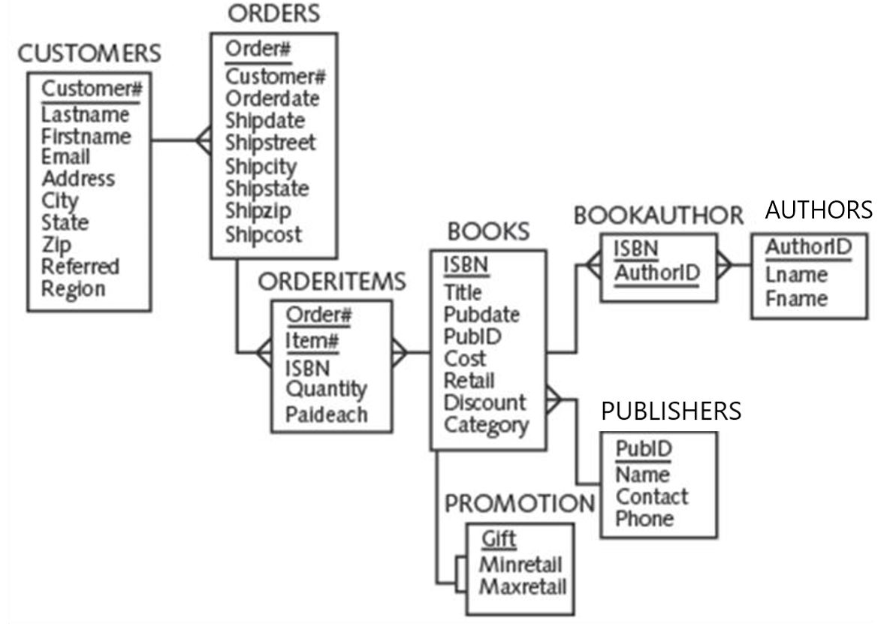

There are two methods of joining tables: **implicit (traditional) and explicit join approaches**. In this lab assignment, you will use the implicit join approach to performing the joining operations. (You will be using the second method to perform table joining operations in the next lab assignment.)

In order to display the output exactly the same as the format shown in various questions, you need to first define a sufficient line size and page size. Type in the following command at the SQL> prompt before running your query:

*SQL> set linesize 200*

*SQL> set pagesize 100*

**Queries:**

1. Create a list of **computer books** that **cost over $35.00**. The output should include the title of each book and the name and phone number of the contact at the publisher‘s office for reordering each book. Sort the result in ascending order of book title.

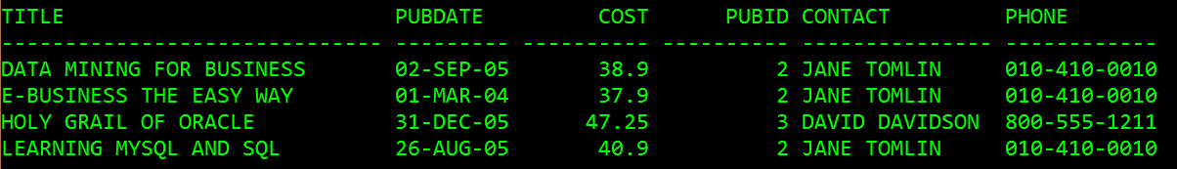

SELECT _________________________________________

FROM __________________________________________

WHERE _____ = _____

AND category = ______

cost > _____

ORDER BY _____;

1. Identify those **orders** that were placed **after April 2015** and **have not been shipped**. The outcome should also include the name of the customer who placed the order. Sort the results in ascending order of order date and customer#.

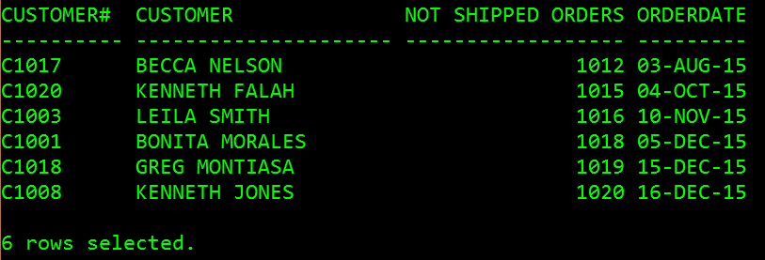

COLUMN "CUSTOMER#" FORMAT A10

SELECT _________________________________________

FROM __________________________________________

WHERE _____ = _____

AND orderdate _____

AND shipdate _____

ORDER BY _____, _____;

1. Produce a list of those customers who **live in Florida** and **have ordered at least one computer book**. The outcome should also include book title, order#, and order date. Sort the result in ascending order customer#.

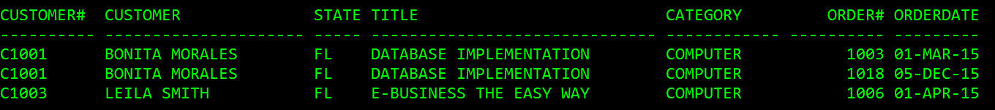

COLUMN state FORMAT A5

SELECT _________________________________________

FROM __________________________________________

WHERE _____ = _____

AND _____ = _____

AND _____ = _____

AND state _____

AND category _____

ORDER BY _____;

1. Determine the **profit** of each book **sold to Jake Lucas**, where **profit = paideach – cost**. Sort the results in ascending order of order date. If more than one book was ordered on the same date, sort the results by profit amount in descending order.

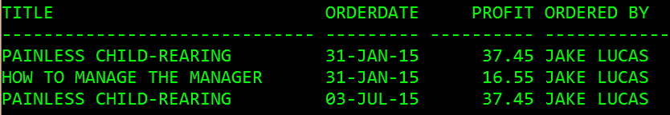

SELECT b.title, o.orderdate, (oi.paideach – b.cost) profit, c.firstname || ‘ ‘ || c.lastname “Ordered By”

FROM books b, orders o, orderitems oi, customers c

WHERE c.customer# = o.customer#

AND o.order# = oi.order#

AND _____ = _____

AND firstname LIKE (‘JAKE’)

AND lastname LIKE (‘LUCAS’)

ORDER BY asc orderdate;

1. List the **authors** of the books **ordered by Becca Nelson or Tammy Giana**. Only those books **with a discount** are included. (Those books without a discount will be excluded.) Sort the result in ascending order of author name.

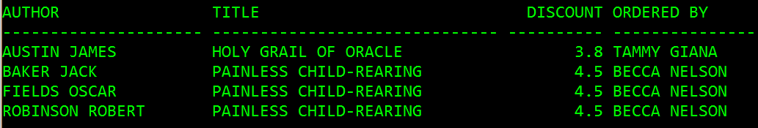

SELECT

FROM __________________________________________

WHERE _____ = _____

AND _____ = _____

AND _____ = _____

AND _____ = _____

AND _____ = _____

AND firstname || ' ' || lastname IN (_____, _____)

AND discount _____

ORDER BY _____;